
Bedale Osteopaths Exercise Sheet 6
Neck and Shoulder Stretches

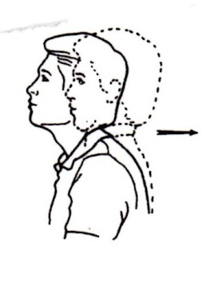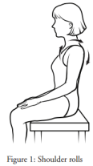
Chin/Jaw Retraction Shoulder Rolls
Tuck chin in, keeping eyes level. Circle the shoulders forwards 4-5 times then backwards.
Hold for 2-3 seconds, repeat 10-15 times. Do more backwards than forwards. Repeat 20 times.
Keep them gentle and slow.

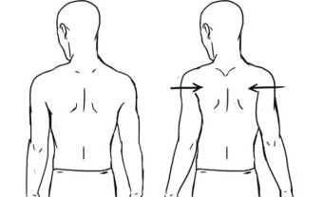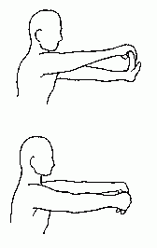

Shoulder Blade Stretch Forearm Flexor Stretch (top)
Hold for 4-5 seconds, repeat 10 times. Forearm Stretch - back of the arm (bottom)
Hold for 10-20 seconds on each.

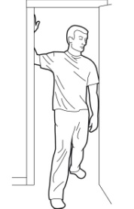 . 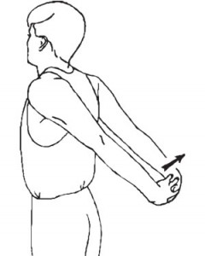
Pectoral Muscle Stretch Chest and Upper Arm Stretch
Feel the stretch at the front of the chest. 2-3 times, hold for 20 seconds each time.
You can increase the stretch by breathing deeply. 2-3 reps for 20 seconds.

These exercises should not be painful. If you are unsure of how to do them speak to your practitioner.
Tel: 01677 425858 www.bedaleosteopaths.co.uk info@bedaleosteopaths.co.uk

