
Bedale Osteopaths Exercise Sheet 3
Low Back Mobilisation
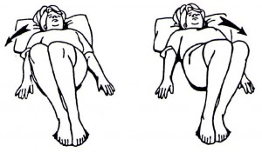

1. Gently and slowly rock your knees from side to side for 1-2 minutes. Keep the movements quite small. This exercise will help to limber up your low back.

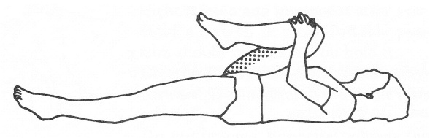
2a. Bring your knee towards your chest and hold for 10 seconds to feel the the stretch in your low back.
2b. Bring your left knee towards your right elbow hold for 10 seconds seconds seconds then change over.
2c. Bring both knees towards your chest and gently rock side to side to limber and massage your spine.

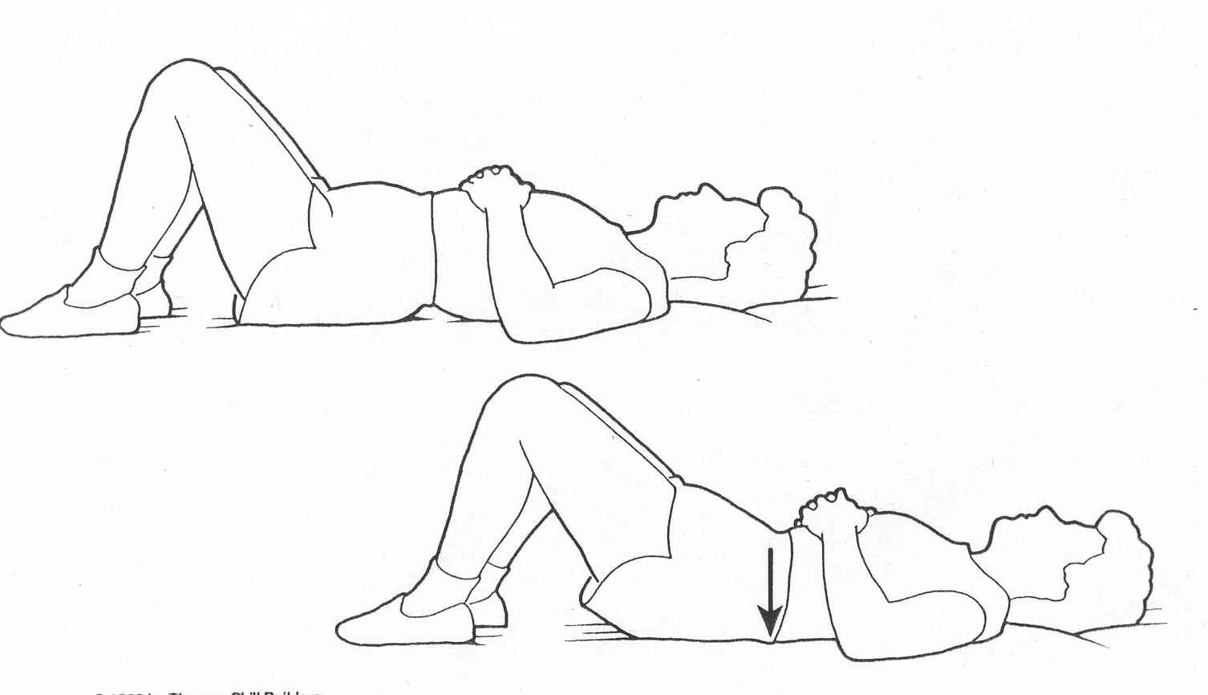

3. Pelvic Tilt: Lie on your back with your knees bent. Slowly push your back back down. You are trying to flatten out the curve in your lower spine. spine. Repeat 6-10 times.

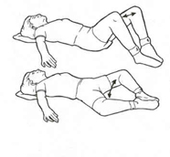
4. Adductor stretch. Drop both your knees outwards, feel the stretch in your inner thigh muscles, hold for 10 seconds.

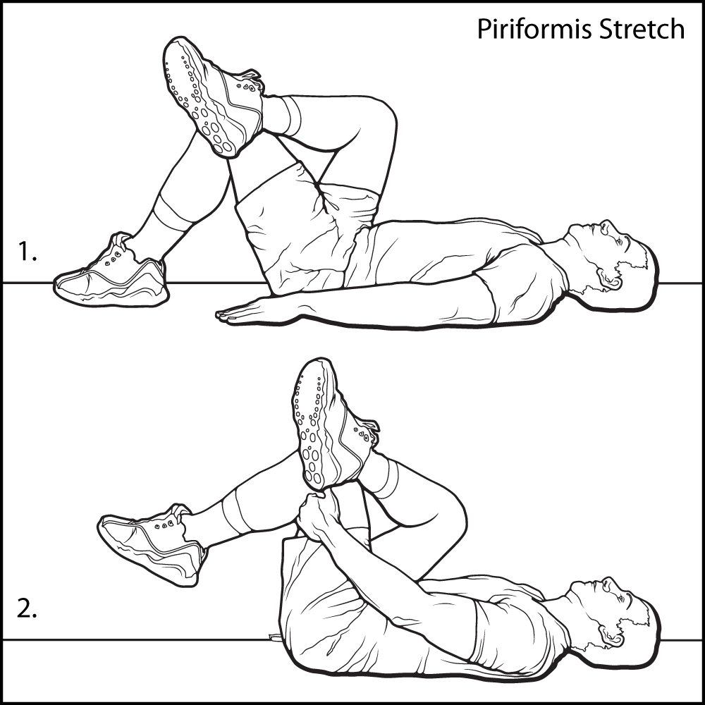
5. Cross your left leg over your right and let the legs drift to the left side. Feel the stretch in the right outer thigh and low back.

6. Put your right ankle on your left knee. Bring your left knee towards your chest and feel the stretch into your right buttock. Hold for 5-10 seconds.

These exercises should not be painful. If you are unsure of how to do them speak to your practitioner.
Tel: 01677 425858 www.bedaleosteopaths.co.uk info@bedaleosteopaths.co.uk

