Bedale Osteopaths Exercise Sheet 8
Low Back Strengthening

The pelvic floor muscles are key to strengthening your back muscles. You can learn to 'engage' your pelvic floor muscles by pulling up and in with your underneath muscles or by gently pulling your low tummy area towards your spine. Lie with your knees bent and 'engage' your pelvic floor, on your out breath, hold the contraction for a few seconds and try breathing normally. Once you are happy that you know how to engage the pelvic floor muscles, practise contracting them to 100%, then to 50% then to 30%. Ideally do the following exercises with the pelvic floor engaged to about 30% of a full contraction.

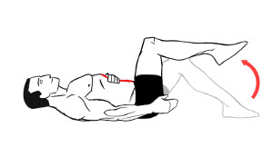
Single leg raise: Breathe in, breathe out, engage pelvic floor and then raise one leg, hold for 5 seconds, lower in a slow and controlled manner, repeat with the other side.
You can progress to double leg raise: breathe in, breathe out, raise one leg, then the other and hold for 10 seconds, then slowly lower one leg at a time.

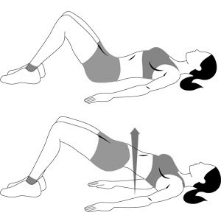
Breathe in, breathe out, engage pelvic floor, roll your hips and pelvis up off the floor, hold for 10 seconds and slowly lower, repeat 5-10 times.

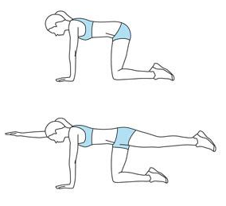

a) With your pelvic floor engaged, stretch out your arm and hold for 10 seconds, lower and repeat with the other arm and then with each leg 5-10 times. This exercise strengthens the back muscles and your co-ordination skills.

b) Raise opposite arm and leg at the same time.

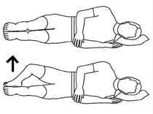

Lie on your side with a straight back and the soles of your feet in line with your bottom, engage your pelvic floor. Keeping ankles together, raise the top knee 5-10cm towards ceiling, hold 5-10 seconds. Repeat 10 times.

These exercises should not be painful. If you are unsure of how to do them speak to your practitioner.
Tel: 01677 425858 www.bedaleosteopaths.co.uk info@bedaleosteopaths.co.uk

