Bedale Osteopaths Exercise Sheet 5
Shoulder and Arm Stretches

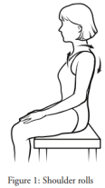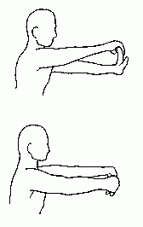
Shoulder Rolls Forearm Flexor Stretch (top)
Circle the shoulders forwards 4-5 times then backwards. Forearm Stretch - back of the arm (bottom)
Do more backwards than forwards. Repeat 20 times. Hold for 10-20 seconds on each.
Keep them gentle and slow.
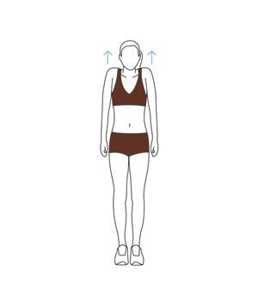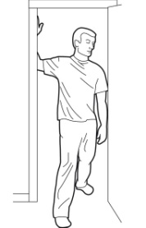
Shoulder Shrugs Pectoral Muscle Stretch
Shrug up for 2 seconds, down for 4 seconds, 5-10 reps. Feel the stretch at the front of the chest.
You can increase the stretch by breathing deeply. 2-3 reps for 20 seconds.

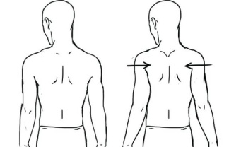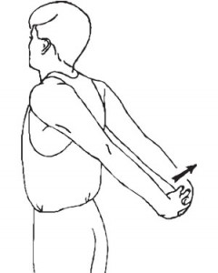

Shoulder Blade Stretch Chest and Upper Arm Stretch
Hold for 4-5 seconds, repeat 10 times. 2-3 times hold for 20 seconds each time.

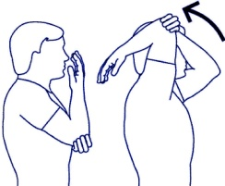

Tricep Stretch
Only go as far as you feel comfortable. Feel the pull at the back of your arm, hold for 20 seconds.

These exercises should not be painful. If you are unsure of how to do them speak to your practitioner.
Tel: 01677 425858 www.bedaleosteopaths.co.uk info@bedaleosteopaths.co.uk

