Bedale Osteopaths Exercise Sheet 4
Hip Strengthening and Mobility

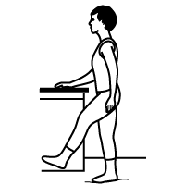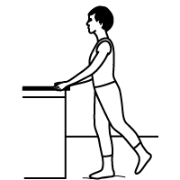

Hip Flex Hip Extension
Take leg forwards, hold 2-3 Take leg backwards, hold 2-3 seconds. Repeat 10-20 times. seconds. Repeat 10-20 times.

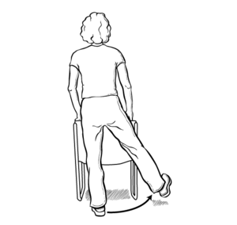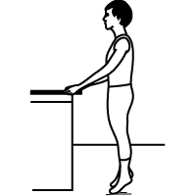

Hip Abduction Tip Toes
Take leg out to the side, hold 2-3 Raise up onto tip toes, repeat 10-20 times.
seconds. Repeat 10-20 times.

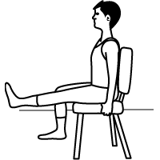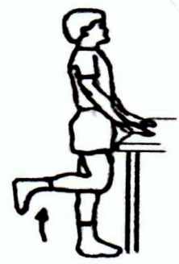

Quad Exercises Hamstring Strengthening
Gently raise foot and hold for 2-3 seconds. Bring your heel up towards your bottom
Repeat 10-20 times. hold for 2-3 seconds.
Variations: turn foot slightly in and repeat. Repeat 10-20 times.
turn foot slightly out and repeat.

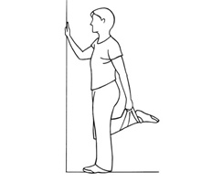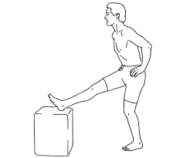
Quad Stretch Hamstring Stretch
Hold for 20-30 seconds. Hold for 20-30 seconds.
2-3 times each side. 2-3 times each side (can use a small step).
These exercises should not be painful. If you are unsure of how to do them speak to your practitioner.
Tel: 01677 425858 www.bedaleosteopaths.co.uk info@bedaleosteopaths.co.uk

