Bedale Osteopaths Exercise sheet 7
Post Pregnancy Exercises

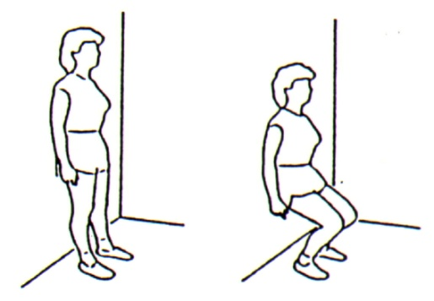

Wall Squats: Stand against a wall with feet hip width apart. Gently slide down all then return to start position. Repeat 10 - 15 times.

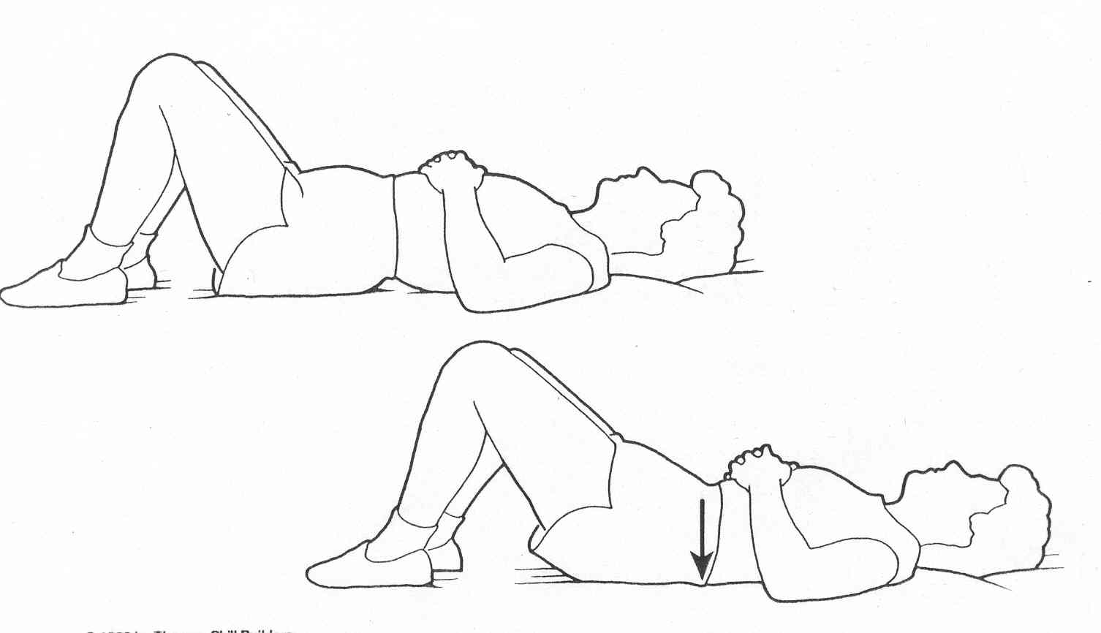

Pelvic Tilt: Lie on your back with your knees bent. Slowly push your back down . You are trying to flatten your out the curve in your lower spine. Repeat 6-10 times.

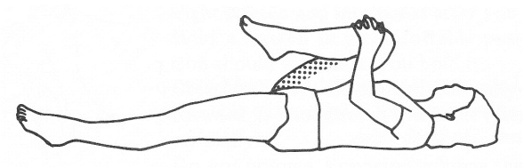
Bring your knee towards your chest and hold for 10 seconds to feel the stretch in your low back.
Bring your left knee towards your right elbow hold for 10 seconds then change over .
Bring both knees towards your chest and gently rock side to side to limber and massage your spine.

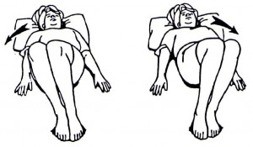
Gently and slowly rock your knees from side to side for 1 -2 minutes. Keep the movements quite small. This exercise will help to limber up your low back.

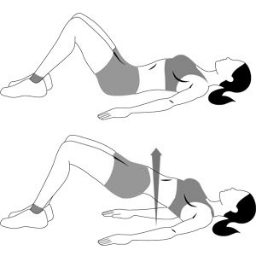
Breathe in, breathe out engage pelvic floor, roll your hips and pelvis up off the floor, hold for 10 seconds and slowly lower, repeat 5-10 times.

These exercises should not be painful. If you are unsure of how to do them speak to your practitioner.
Tel: 01677 425858 www.bedaleosteopaths.co.uk info@bedaleosteopaths.co.uk

