Bedale Osteopaths exercise sheet 2
Knee Stretches/Strengthening Exercises

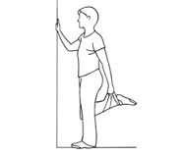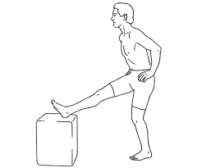
Quad Stretch Hamstring Stretch
Hold 20-30 seconds Hold 20-30 seconds
2-3 times each side 2-3 times each side (can use a small step)

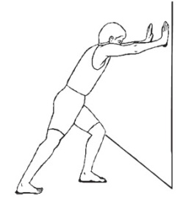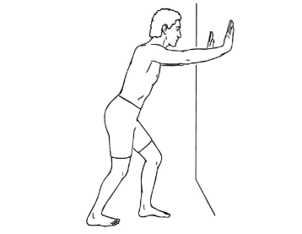
Gastroc Stretch Soleus Stretch
Stand with right foot back and leg straight This time you will bend both knees keeping heels
keeping heel on the floor. on the floor. 20- 30 seconds, 2-3 times.
Lean into the wall bending left knee until
stretch is felt in right calf. Hold for 20-30 seconds, 2-3 times.

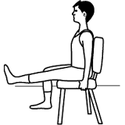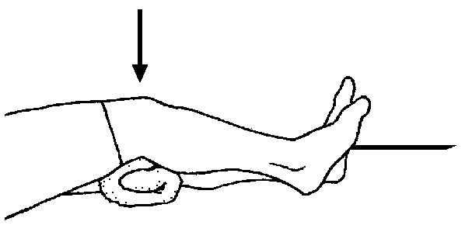

Quad Exercises Quadriceps Set
Gently raise foot and hold for 2-3 seconds. Repeat Cushion under the knee and push down into the cushion
10-20 times. and hold for 3-5 seconds
Variations: turn foot slightly in and repeat Repeat 10-20 times
turn foot slightly out and repeat

Wall Squats
Stand against a wall with feet hip width
apart. Gently slide down wall then return
to start position.
Repeat 10-15 times.

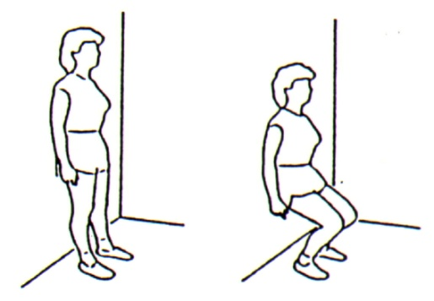

These exercises should not be painful. If you are unsure of how to do them speak to your practitioner.
Tel: 01677 425858 www.bedaleosteopaths.co.uk info@bedaleosteopaths.co.uk

