Bedale Osteopaths exercise sheet 1
Leg Exercises

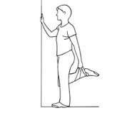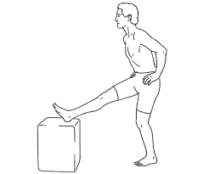
Quad Stretch Hamstring Stretch
Hold for 20-30 seconds, 2-3 times on each side Hold 20-30 seconds
2-3 times each side (can use a small step)

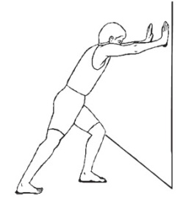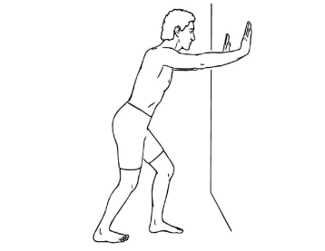
Gastroc Stretch Soleus Stretch
Stand with right foot back and leg straight This time you will bend both knees keeping heels
keeping heel on the floor. Lean into the on the floor. 20- 30 seconds, 2-3 times.
wall bending left knee until stretch is felt
in right calf. Hold for 20-30 seconds, 2-3 times.

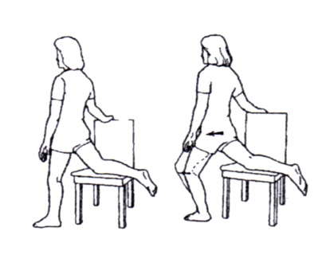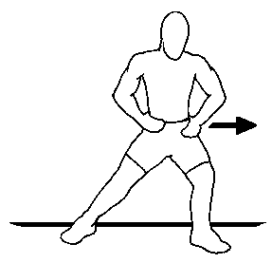
Front of the hip and thigh stretch Inner thigh stretch
Keep your head up, bend your knee forward keeping Stand with legs hip width apart. Lean left and hold for
your pelvis straight, you should not feel 20-30 seconds. Repeat on each side.
any pain in your low back.
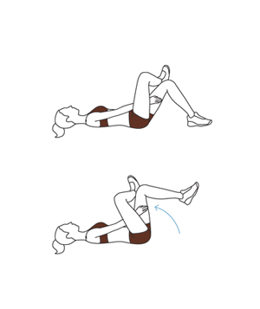
Gluts Stretch

Lie on you back and place your right ankle on your left knee, lift your left leg up off the floor, you should feel the stretch in your right buttock. Hold for 20-30 seconds. Repeat on the other side.

These exercises should not be painful. If you are unsure of how to do them speak to your practitioner.
Tel: 01677 425858 www.bedaleosteopaths.co.uk info@bedaleosteopaths.co.uk

